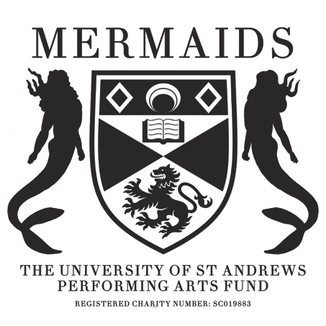

Production Proposal Form
2020-2021

As a matriculated student of the University of St Andrews, you have the opportunity to propose any show to the Mermaids Performing Arts Fund, and we will do everything we can to try and help you make it a reality. At this stage, you need to fill in this Production Proposal Form, a Budget Form and a Risk Assessment Form. Please make sure you include as much detail as you can, particularly in Section 3 (production ideas) – the more you include the more likely it is that we will fund your play.

If you have any questions or concerns, don’t hesitate to email our Productions Co-ordinator, Juliet Boobbyer (jb335@st-andrews.ac.uk) and she’ll help you out.

Section 1: Production details
Name of Production:
Author:
Forty Word Blurb (including title):

Do you have any preferences for performance dates? If so, why?

Proposed Venue:

Cast numbers (male/female/neutral parts):

Would you be willing to cast gender-blind/gender-neutral?

Approximate run time:

Why this play?

Why this venue?

Do you require Production Rights for this piece?

If yes, have they been requested? *Please attach any correspondence*

Owner/Handler of Rights and Contact Details:

Will you be seeking funding from another body to support this production? (Antony Tudor, for instance).

Section 2: Production team
All production teams must have a director, producer, publicity co-ordinator (this role can be doubled up for Barron), and technician (for advice on finding a technician, contact the Mermaids Technical officer). We would also suggest thinking about having a stage manager, costumer and designer should your show need these team members. Please tell us about your team’s previous experience in as much detail as you can, and include contact information. If you are proposing as a production company, please mention this here too!

Director (Name/Email):

Producer (Name/Email):

Publicity-Coordinator (Name/Email):

Technician (Name/Email):

Other Team Members (Name/Email):

Section 3: Production Ideas
This gives us a chance to share your creative vision for the production, and also understand your budget form in a more detail. We do not expect your ideas to be set in stone at this early point, but we hope that your budget won’t change drastically from what is passed, so think through what you need. The best way to think about this is to present an act-by-act break-down of what you will need. Please meet with the appropriate committee members (details below) to check that your estimates are realistic.

Set (Contact the Mermaids Set & Props Officer for advice):

Props (Contact the Mermaids Set & Props Officer for advice):

Costumes (Contact the Mermaids Costumes Officer for advice):

Make-up/Hair (Contact the Mermaids Costumes Officer for advice):

Lighting (Contact the Mermaids Technical Officer for advice):

Sound (Contact the Mermaids Technical Officer for advice):

Section 4: Marketing Plan
Please include ideas for how you would market your play. Include ideas for graphic design, and both social media and any physical publicity.

Section 5: Engagement and Outreach
Please detail any ideas you have to collaborate with any other societies, subcommittees or charities. This could include joint events such as socials or discussions, awareness talks, joint publicity or including them in the programme. Furthermore please attach any correspondence you have had with them. Please explain how these actions will expand your reach within the student body and engage new sets of students. Whilst it is not necessary, we definitely encourage collaboration and supporting other societies, subcommittees and charities..

Section 6: Committee Correspondence
Who on the committee have you spoken to already?

Committee Contact Details

President: Martin Caforio (merpres@/mc335@)
Vice President: Isabella Zeff (isz@)
Productions Co-ordinator: Juliet Boobbyer (jb335@)
Treasurer: Isabelle Molinari (ijm20@)
Technical Officer: Adia Folsom (af230@)
Set and Props: Natasha Maurer (merprops@/nm208@)
Costume and Make-up: Noemie Jouas (njy3@)
Marketing Officer: Georgie Turner (gt72@)
Barron Manager: Cate Hanlon (barron@/clh24@)
Box Office Manager: Molly Luckhurst (barronboxoffice@/ml279@)
Ball Convener: Natalie Christopher (nac7@)
Secretary: Molly Ketcheson (mermaids@/mcak@)
Engagement Officer: Molly Williams (mrw7@)
Fringe Representative: Joscelyn Hyam (jmh33@)

